**5 Natural dynamics of ID (Measles)**

Set up the SEIR model with births and deaths for the transmission dynamics of measles in a closed population using differential equations:

Population 100000 people

Pre-infectious period 8 days

Infectious period 7 days

Basic reproduction number 13

Life Expectancy 70 years

Initial values (S,E,I,R)=(99999,0,1,0)

Using the parameters above, plot a graph from the 40th year to the 50th year which illustrates your answer for each question.

1. How does the net reproduction number change over time? What is the value of the net reproduction number when the daily number of new infectious peaks? What is its value when the daily number of new infectious persons reaches a trough?

*Answer:*

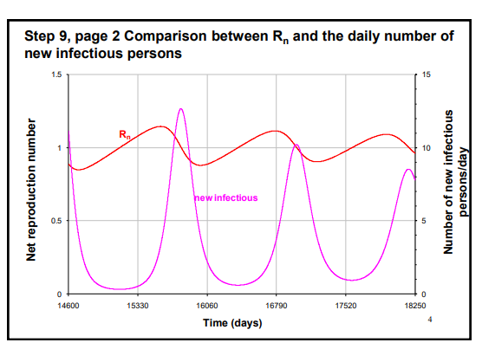

*The net reproduction number fluctuates by passing 1. When the daily number of new infectious reaches peaks or a trough, it is equal to 1.*

1. What is the trend in the daily number of new infectious when Rn<1, Rn>1, and Rn=1, respectively?

*Answer:*

*When the net reproduction number is smaller than 1, the daily number of new infectious decrease. If `Rn`>1, then it increase. For `Rn`=1, it reaches a peak or trough.*

1. What proportion of the population is susceptible to infection when the daily number of new infectious peaks or troughs? Is this consistent with what you expect and why?

*Answer:*

*About 0.07. When the daily number of new infectious peaks or troughs, the net reproduction number is equal to 1. If 1 = Rn = S/N R0,*

*we can expect that the proportion of susceptible will be 1/R0.*

1. Calculate the herd immunity threshold in this population.

1-1/R0 = .9231

1. What is the value of proportion of immune when the number of new infectious per day peaks or troughs? What do you notice about the value of proportion of immune when the daily number of new infectious is declining? What is its value when the daily number of new infectious is increasing? How does this relate to your estimate of the herd immunity threshold?

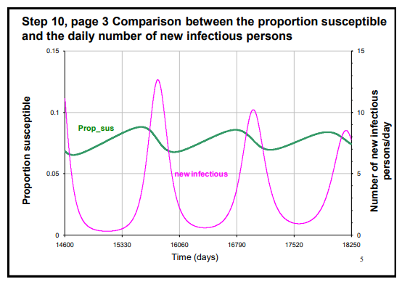

*Answer:*

*About 0.9230. When the daily number of new infectious decrease, the proportion of immune is larger than herd immunity threshold (HIT). If the daily number of new infectious increase, it is smaller than HIT.*

1. What is the long-term equilibrium value for the proportion of the population which is susceptible or immune? How do these values relate to the herd immunity threshold which you have just calculated and why?

*Answer:*

*For susceptible, 0.0769 and for immune, 0.9230.*

*The herd immunity threshold is equal to 0.923, which is same as the long-term equilibrium value for proportion of immune. Since HIT is the theshold of proportion of immune to protect susceptibles, there is no more infectious people and it becomes the equilibrium state when the proportion of immune is equal to HIT.*

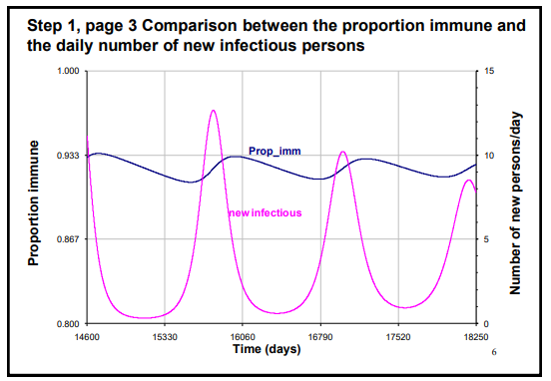

Modify the model to include the vaccination which is introduced 50 years after the infection has been circulating in the population so that a proportion of newborn individuals are effectively vaccinated. Run the model for 80 years and plot the proportion of immune and the number of new infectious on each side of y-axis.

1. What happens to the number of new infectious persons per day if the proportion of the population which is effectively vaccinated is below (60%, 90% coverage) the herd immunity threshold? What happens to the number of new infectious persons per day if this proportion is above (93% coverage) the herd immunity threshold?

*Answer:*

*The daily number of new infecitous people increase slowly when the efficacy is below HIT. Also, it maintain zero values if the proportion is above the HIT.*

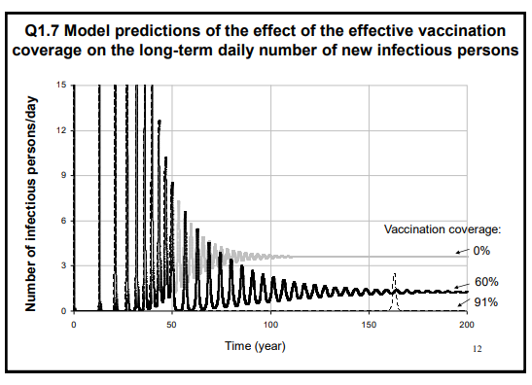

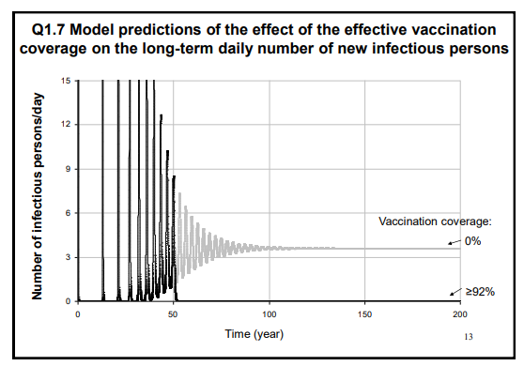

To explore how R0 and other factors (e.g. the vaccination coverage, the birth rate in the population) affect the inter-epidemic period, reset the proportion of the population which is vaccinated to be zero.

1. What is the inter-epidemic period 50-100 years after the introduction of one infectious case into this population? Are your results consistent with the following formula provided by Anderson and May?

$$T=2π\sqrt{\frac{L(D+D^{'})}{R_{0}-1}}$$

where D’ is the average duration of the pre-infectious period, D is the average duration of infectiousness, L is the life expectancy.

*Answer:*

*About 3 years. It is consistent with our results since there are 13 peaks from 50 years to 100 years after the introduction of vaccination.`*

1. R0 for measles was estimated to be about 5-6 in Kansas 1918-9, and 18 in England and Wales in 1950-68. Run the model for values of R0 of 5 and 18. How does the inter-epidemic period resulting from an R0 of 18 compare against that resulting from an R0 of 5? Why might this occur?

*Answer:*

*For R0 = 5, the inter-epidemic period is 5.33 years and it is much larger than R0 of 18 case (2.58 years). This is because large R0 leads to small T. Also, since the 1/R0 is larger, it takes more time to gather enough number of susceptible.*

1. How might you expect the introduction of vaccination to affect the inter-epidemic period?

*Answer:*

*The introduction of vaccination leads to increase of age at infection A. This results in decrease of R_0=1+L/A and increase of inter-epidemic period. Also, it takes more time to obtain enough number of susceptible because a lot of newborns are immune.*

1. How might the birth rate in the population influence the inter-epidemic period? Test your hypothesis by changing the birth rate assuming that the population size remains constant over time.

*Answer:*

*The small value of birth rate means that we need more time to obtain enough susceptible to generate infectious people. This leads to larger value of inter-epidemic period. Also, considering the formula of inter-epidemic period, the life expectancy is proportional to inter-epidemic period.*

1. Would you expect the inter-epidemic period for measles to be shorter than that for chickenpox? mumps? rubella? Why?

*Answer:*

*Since R0 for chickenpox (3-4), mumps(3-4) and rubella(4-5) are smaller than measles, the inter-epidemic period for measles will be shorter.*

1. Change the parameters to be those for influenza (pre-infectious and infectious periods of

2 days and a basic reproduction number of 2), reset the birth rate corresponding to a life expectancy of 70 years and, making sure that no-one is vaccinated in the population. Why might you be cautious about using predictions of the inter-epidemic period for influenza from this model?

*Answer:*

*The formula can be applied only for immunizing infections. Since influenza do not confer immunity against reinfection, this logic is not easily extendible.*